Cloud Deployable Collegiate Cyber Defense Competition Practice Range

Charles Danner
Whatcom Community College
CIS 405: Cloud Computing
Kathleen Czurda-Page
3/25/2026

Cloud Deployable Collegiate Cyber Defense Competition Practice Range

Original Project Definition
The project began as an attempt to manually build a Collegiate Cyber Defense Competition (CCDC) practice environment. The initial plan was to create and configure virtual machines by hand, run scripts to introduce security vulnerabilities, and take snapshots so the environment could be reset between practice sessions. When copies of virtual machines from previous CCDC competitions were found online, those were tested as a shortcut (Western Regional CCDC, n.d.). However, none of them came with documentation, the virtual hardware had to be reconfigured manually for each machine, and the router's network address translation could not be made to work correctly. A CCDC environment designer recommended Ludus as a better approach. From that point the project shifted to building a fully automated range using Proxmox, Ludus, Ansible, and Claude Code.
Changes Made During the Project
Following the Ludus tutorials and writing configuration files and Ansible roles by hand proved to be extremely slow and had a steep learning curve. After initial progress stalled, the workflow shifted to using Claude Code to generate the range configuration and Ansible roles. This change made it possible to produce a working environment far more quickly. The scope also grew beyond the original proposal. A custom scoring engine was added because real CCDC competitions use an automated system that checks whether services are still running and awards points for uptime (Sshell, 2025). A referee toggle was added to the scoring dashboard to hide diagnostic details from the blue team during practice, which mirrors how real competitions work.
Final Scope
By the end of the project the following was completed: Ludus installed and running on a local Proxmox host; a Windows Active Directory domain with a domain controller and a Windows 11 workstation; five Linux service machines running web, database, file sharing, mail, and FTP services; a Kali Linux attacker machine loaded with a full penetration testing toolset; a custom Python based scoring engine that checks eleven services every thirty seconds; a live web dashboard showing service status and uptime history; and a referee toggle to hide diagnostic details from blue team players. All nine virtual machines are spread across two isolated networks and configured entirely through Ansible roles. Because Ludus supports deployment to any compatible host, this same environment can be redeployed to Azure, bare metal servers, Google Cloud Platform, Hyper V, Proxmox, and VMware Fusion without changes to the configuration.
Key Decisions and Why
The most important early decision was to stop building the environment by hand and adopt Ludus as the base platform. The manual approach required configuring every virtual machine individually, managing templates and snapshots without automation, and debugging networking problems that had no clear solution. Ludus replaced all of that with a single configuration file and automated provisioning. This is the same infrastructure as code model that cloud platforms like Azure and Google Cloud use. Describing the entire environment in a file and letting a tool build it automatically is what makes the range portable across platforms.
The decision to use Claude Code rather than write Ansible roles manually was equally important. Manual role writing stalled progress because of the large number of tasks needed to configure Active Directory, Linux services, and network settings correctly. Claude Code generated working role structure quickly, suggested fixes when tasks failed, and made it possible to finish all ten roles on schedule. Running a full system upgrade before installing tools on the Kali Linux machine was a smaller but necessary decision made after package dependency errors blocked installation.
Tools and Software Used
Proxmox Virtual Environment is the hypervisor that runs all of the virtual machines in the range. It creates and manages the VMs and provides the virtual networking that keeps the corporate network and the attacker network separated. Proxmox is also the platform that Ludus runs on, making it the foundation for everything else in the project.
Ludus Cyber Range sits on top of Proxmox and automates the creation of the entire range from a single configuration file. Ludus creates each machine from a template, places it on the correct virtual network, and calls Ansible to finish configuration. Ludus follows the same infrastructure as code model used by cloud providers and supports deployment to Azure, bare metal servers, Google Cloud Platform, Hyper V, Proxmox, and VMware Fusion. This makes the range portable to any platform where Ludus can run (Ludus, n.d.).
Ansible configures each virtual machine after it is created by Ludus. The ten Ansible roles written for this project cover every machine in the range, from the domain controller to the FTP server. Each role also applies intentional security weaknesses so the blue team has realistic problems to find and fix. Ansible makes the entire configuration repeatable because it always runs the same steps in the same order from files stored in the repository.
Claude Code was used to write and debug the Ansible roles and the Ludus configuration file. Writing roles for Windows Active Directory and multiple Linux services involves many tasks, module options, and edge cases that are difficult to get right manually. Claude Code generated role structure, suggested fixes when tasks failed, and translated competition service requirements into working Ansible code. It made completing all ten roles within the project timeline possible.
Diagrams
Figure 1 below shows the full network layout of the range. It includes the Debian router that connects the WAN, VLAN 10, and VLAN 99, along with each virtual machine labeled with its IP address, operating system, purpose, and key ports.
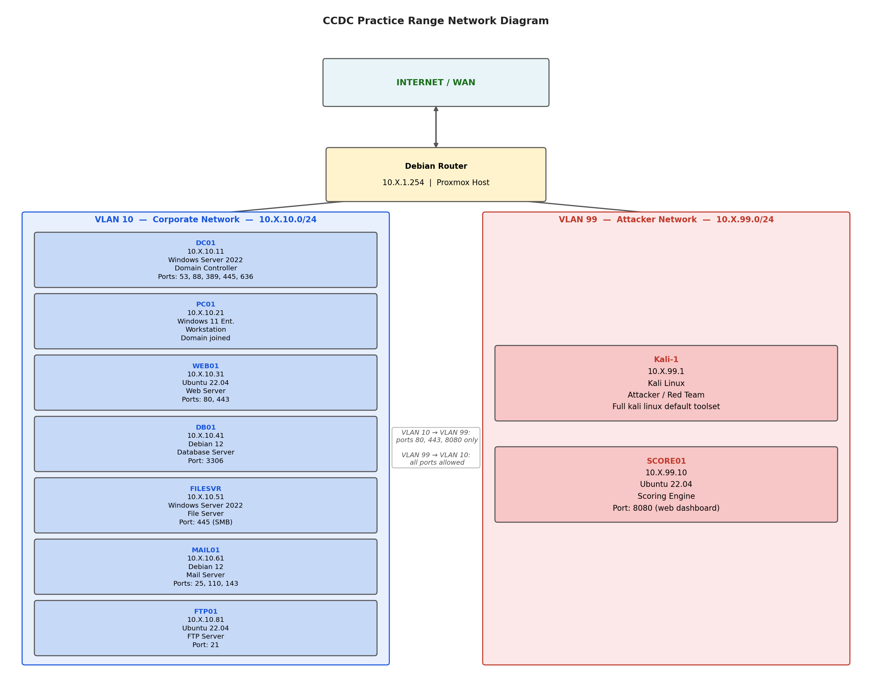
Figure 1. CCDC Practice Range Network Diagram
Code and Configuration Steps
All configuration files live in the project repository. The main range configuration file defines every virtual machine, its VLAN, its IP address, and which Ansible roles to run on it. The ten Ansible roles are in the roles folder, one subfolder per machine. Each role subfolder contains a tasks file with the configuration steps, a defaults file with variable defaults, and a templates folder with config files for services like Apache, Postfix, and the scoring engine. No configuration is done by hand; every setting is driven by these files.
Installation and Deployment Instructions
Teams that have not yet installed Ludus should begin with the Ludus quick start guide at https://docs.ludus.cloud/docs/quick-start/
Full deployment instructions for this range are available in SETUP.md in the project repository. https://github.com/Cdanner7766/Ludus-AD-Range-Configured
At a high level, deployment involves five steps. First, install Ludus on a Proxmox host and build the five required virtual machine templates (Ludus, n.d.). Second, clone the project repository onto the Ludus host. Third, register the ten Ansible roles from the repository with Ludus. Fourth, apply the range configuration file to define the virtual machines and networks. Fifth, run the range deploy command and allow Ansible to configure each machine automatically. Once deployment finishes, the scoring engine starts on its own as a system service and is reachable on port 8080 from a web browser.

References

Ludus. (n.d.). Introduction to Ludus. https://docs.ludus.cloud/docs/intro/
Ludus. (n.d.). Quick start guide. https://docs.ludus.cloud/docs/quick-start/
Sshell. (2025). Red teaming at national CCDC 2025. https://www.sshell.co/red-teaming-at-national-ccdc-2025/
Western Regional CCDC. (n.d.). WRCCDC VM image archive. https://archive.wrccdc.org/images/
Winterknight. (n.d.). How to win CCDC. https://www.winterknight.net/how-to-win-ccdc/

